The Curious Case of the dreaded Giffen Good Paradox

The “Law of Demand” states that if the price of a good should rise, its quantity demanded should fall and where the price of a good should fall, its quantity demanded will increase; resulting with a downward sloping demand curve. The Law of Demand has long been the foundation of microeconomics. However, in the case of the “Giffen Good paradox”, “Giffen Goods” have an upward sloping demand curve due to their nature that is when the price of the good increases, the quantity demanded also increases it thus violates the “Law of Demand”. (Jensen & Miller 2008). A likely occurrence of the dreaded “Giffen Good” was during the 1845-49 potato famine in Ireland, during which families who consumed potatoes ended up consuming more simply because potatoes were considered a “necessity of life” and since its price rose, they were unable to afford meat. Many have attributed the Irish potato example to Robert Giffen, a Scottish economist and statistician (Dwyer & Lindsay 1984). Poorer consumers facing subsistence concerns are more likely to face an upward sloping demand curve. For example, if a rise in the price of bread makes such a large decrease in real income for the already poor consumer and raises the marginal utility of money for them, they are forced to decrease their consumption of more expensive foods such as meats and vegetables. These poorer consumers will then end up consuming more of bread which is the “Giffen Good” in this example and, not less of it (Marshall, 1895).

For a good to be Giffen, it must be inferior. Its income effect must be so great that it offsets its substitution effect. This is because if its substitution effect is greater than the income effect, then consumers will be able to substitute to another good thus not ending up consuming more of it. The term “Giffen behaviour” can be used to stress that the Giffen property lies with consumer behaviour through certain circumstances including real income, price of goods and marginal utility of money. This is important to understand so we can see how the Giffen property is dependent on the consumer’s situation. There are certain parameters that are required to give rise to the Giffen Good paradox, these include: Households are so poor, that they face subsistence nutrition concerns, households have a simple diet consisting of an essential good and a fancy good and the essential good has no substitutes and is the cheapest source of calories making up most of their budget. However, in some extreme cases of poverty, there is no existence of Giffen behaviour or a Giffen good even if the three parameters stated above hold. Consider a poor consumer who only consumes bread, if they do not consume a fancy good, they will not be able to exhibit Giffen behaviour. So, when the price of bread rises, the poor consumer will have no choice but consume less bread. Finally, the last parameter is that households must not be so impoverished that they do not consume a fancy good (Jensen & Miller 2008). The theory of the Giffen Good paradox therefore predicts that those who are poor but not too poor will exhibit Giffen behaviour.

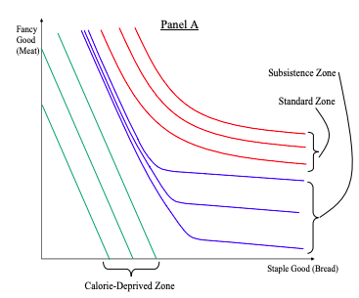

*Figure 1.* Title of article from which

Panel A illustrates an individual’s indifference curves for a consumer choosing how much of the staple good and fancy good they want to consume. The staple good provides the consumer with the basic nutrition and calories that they need in order to survive; the fancy good on the other hand offers more “taste” meaning it is more enjoyable but does not offer as much nutrition or calories as the staple good. Over the “standard zone” the consumer’s calorie intake is well above subsistence and thus the consumer trades off between calories and taste in a normal way, shown through the normally shaped indifference curves. As the consumer’s calorie consumption decreases, he enters the “subsistence zone.” Within this area, caloric intake is more important than taste for the consumer. Consumers in the subsistence zone aim to meet their minimum caloric needs while also maximising their taste. This leaves us with an “L” shaped indifference curve which is typical of Giffen Goods. Finally, in the “calorie-deprived zone” the consumer’s calorie intake is below subsistence levels. In this zone maximising calories is the primary concern of the consumer. These indifference curves are effectively iso-calorie curves (Jensen & Miller, 2008).

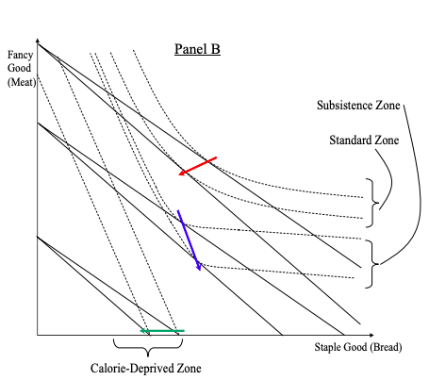

*Figure 2.*

The consumer’s response to an increase in the price of the staple good will be different across the three zones of his indifference map. When the consumer is wealthy they will demand a bundle of goods in the standard zone, they will respond to an increase in price of the staple good by consuming less of it, yielding a normal downward sloping demand curve. Within the subsistence zone, the consumer is not as wealthy and his primary concern is maintaining caloric intake rather than taste. The Giffen behaviour arises within this region as with the rise in price of the staple good, the consumer is left with no option other than to curtail consumption of the fancy good and consume more of the staple good, leaving them with an upward sloping demand curve. Over this region caloric intake is much more important than taste for the consumer, thus they trade caloric intake over taste rather than taste over caloric intake in the standard zone. In the calorie-deprived zone, the consumers wealth decreases even further so that they are unable to meet their subsistence calorie needs. To maximise their caloric-intake the consumer can only consume the staple good as it provides more calories per dollar compared to the fancy good. Here there is no Giffen behaviour because there is only one good that the consumer can afford and he has no choice but to respond to the rise in price but to consume less of it (Jensen & Miller, 2008).

There have been arguments on both sides regarding the extent of which the Giffen Good paradox has existed. Experimental confirmation of the existence of the Giffen Good involved rats choosing between root beer and a quinine solution as the fancy good and staple goods respectively. During the experiment quinine’s price was always kept less than root beer. Rats given unrestricted access to these fluids preferred root beer to the quinine solution. While keeping the price of quinine less than root beer, the rats would be trading off the better tasting root beer against the quinine which when “purchased” was served in greater volumes and also provided more nutrition per mL. Prices of both goods were controlled by two levers, one each for the root beer and quinine solutions. With varying amounts of each liquid coming out with each “press”, the “root beer lever” produced 0.01 mL per press and the “quinine solution lever” would produce 0.05 mL. Income was controlled by limiting the number of presses that the rats would get on each lever (Battalio, Kagel & Kogut, 1991).

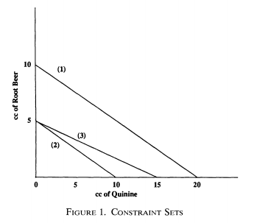

*Figure 3.*

The experiment relied on the inferiority of the quinine as a good. This was explored by lowering the income levels where the low price of quinine as a nutritive source would offset the taste advantage of the root beer and the strong inferiority of quinine was observed. Moving from budget constraint (1) to (2) through reducing effective lever presses this was achieved as the rats had lower income ended up consuming more quinine thus proving the inferiority of the good (Battalio, Kagel & Kogut, 1991).

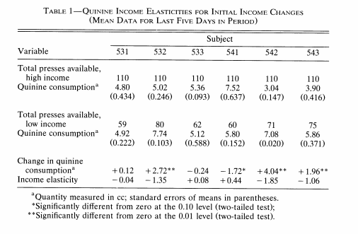The above table reports the income elasticities during the experiment, showing strong inferiority of the quinine consumption for subjects 532, 542 and 543. Once the inferiority of the quinine solution was observed, the effective price of quinine was forced up as the subject’s income was decreased. With the decrease of income, the rats were still able to reach their original level of consumption of the fluid if they switched all consumption to quinine and ended up on its corner solution (Battalio, Kagel & Kogut, 1991).

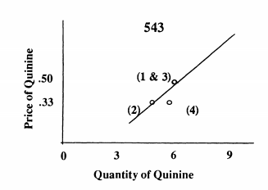

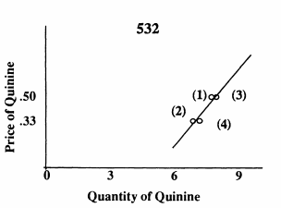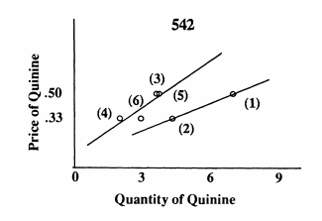

*Figure 4.*

The effects of the income constant reduction and effective rise in the price of quinine yielded an upward sloping demand curve for subjects 532, 542 and 543. An anomaly in modern microeconomics. For subjects 532 and 543 in periods 1-3 a reversible sequence of Giffen points are observed. Period 4 is also Giffen however the strength of the effect is weakened. For subject 542 the first price decrease resulted in a decrease in consumption of the quinine good however it was not as strong as subjects 532 and 543. Further price changes imposed across the next few periods resulted in ultimately producing a Giffen response similar to subjects 532 and 543. The Giffen responses shown in Figure 2 are associated with substantial negative income effects showing the strong inferiority of quinine consumption with very little of the substitution effect (Battalio, Kagel & Kogut, 1991).

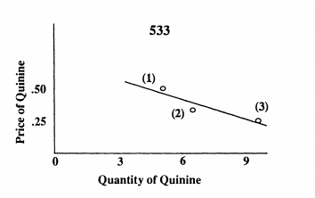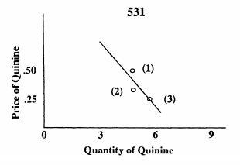

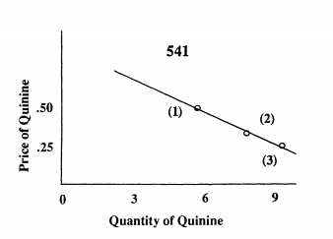

For subjects 531, 533 and 541 a strongly inferior range of consumption was not found and thus this resulted in normal negatively sloping demand curves. Although Giffen behaviour was only observed in half of the subjects, they were strongly correlated with the conditions required in theory to produce a Giffen response: Strong inferiority for the good coupled with a small substitution effect. The data from Table 1 also proves that the Giffen Good paradox is a property of an individual’s preference map given certain situations and is not solely a property of the good itself. This argument is supported by the fact that positively sloped demand curves are observed at low income levels for the rats and negatively sloped demand curves are observed at higher incomes for the same subjects (Battalio, Kagel & Kogut, 1991).

Although there is strong evidence of the Giffen Good paradox in some circumstances, there are also many sufficient arguments against the famous paradox. The Irish famine of 1845-49 has been frequently cited as the first occurrence of the Giffen Good paradox and has often been attributed to Robert Giffen. Giffen failed to commit his suggestion to print, which can be considered strange. The most obvious issue with the legend of the Giffen Good is that during the famine, supply of potatoes would have decreased meaning it would have been impossible for consumers to end up increasing their consumption. This is shown in the diagram below as supply shifts from (S1) to (S2) while price falls. Another issue raised is that if the market demand for potato had been Giffen at the time, then they should have responded to a lower market price by consuming less of the good. With a positively sloped demand curve a decrease supply results in a lower market price and therefore less consumption; this contradicts the narrative of the Giffen Good (Dwyer & Lindsay, 1984).

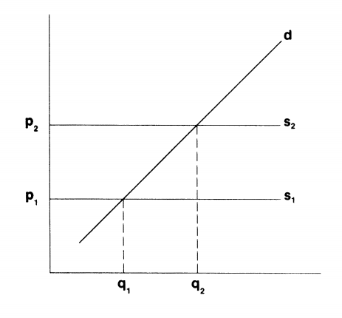

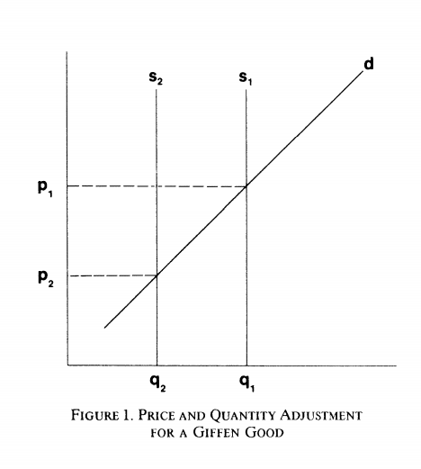

Other arguments that question the extent to which a Giffen Good has existed include the fact that over half of goods are normal and a small amount of goods are inferior. This contradicts the Giffen narrative of consumers consuming more when their supply would ultimately decrease. Inferior goods are also required to take up a large part of a consumer’s income due to the fact that the income effect should be much greater than the substitution effect for Giffen behaviour to be exhibited. Normally though, inferior goods do not make up much of the consumers budget at all. Inferior goods tend to have many substitutes, otherwise consumers would not substitute away from them as the real income rises (Moore, G, 2019).

Overall, it may be said that the legend of the existence Giffen Good paradox is just that, a legend. While there have been experiments conducted to prove its existence, these experiments are conducted within very specific parameters which would be very different from one that a normal consumer would face. Along with this, is the fact that all of the subjects (rats) that the experiment was conducted on were very similar genetically and lived in similar environments historically. This only further adds to the unlikeliness of observing the Giffen Good paradox within human market demand.